

PAYROLL DEDUCTION AUTHORIZATION

Personal Information
Surname |  |  |  |  |  |  |  |  |  |  | First Name
Employer Name |  |  |  |  |  |  |  |  |  |  | Department
Employee Number
Financial Institution Information (please attach a cheque marked “VOID”)
Branch number (5 digits): |  | 00332
Institution number (3 digits): |  | 0828
Account number (12 digits max.):
Attach Void Cheque:
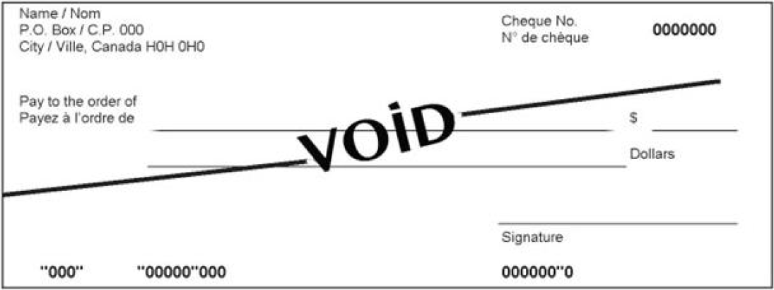

Payroll Deduction Plan
Select what applies:

I authorize to automatically set up a deduction from my pay in the amount of $

I authorize to cancel my deduction of $

I authorize to increase/decrease my deductions from $ to $

Starting on
DD MM YYYY

Employee Signature |  |  |  |  | Name (please print) |  |  |  |  |  |  |  |  |  |  |  |  |  | Date
CU Staff Member |  |  |  |  | E-Mail |  |  |  |  |  |  |  |  |  |  |  |  |  | Telephone Number

